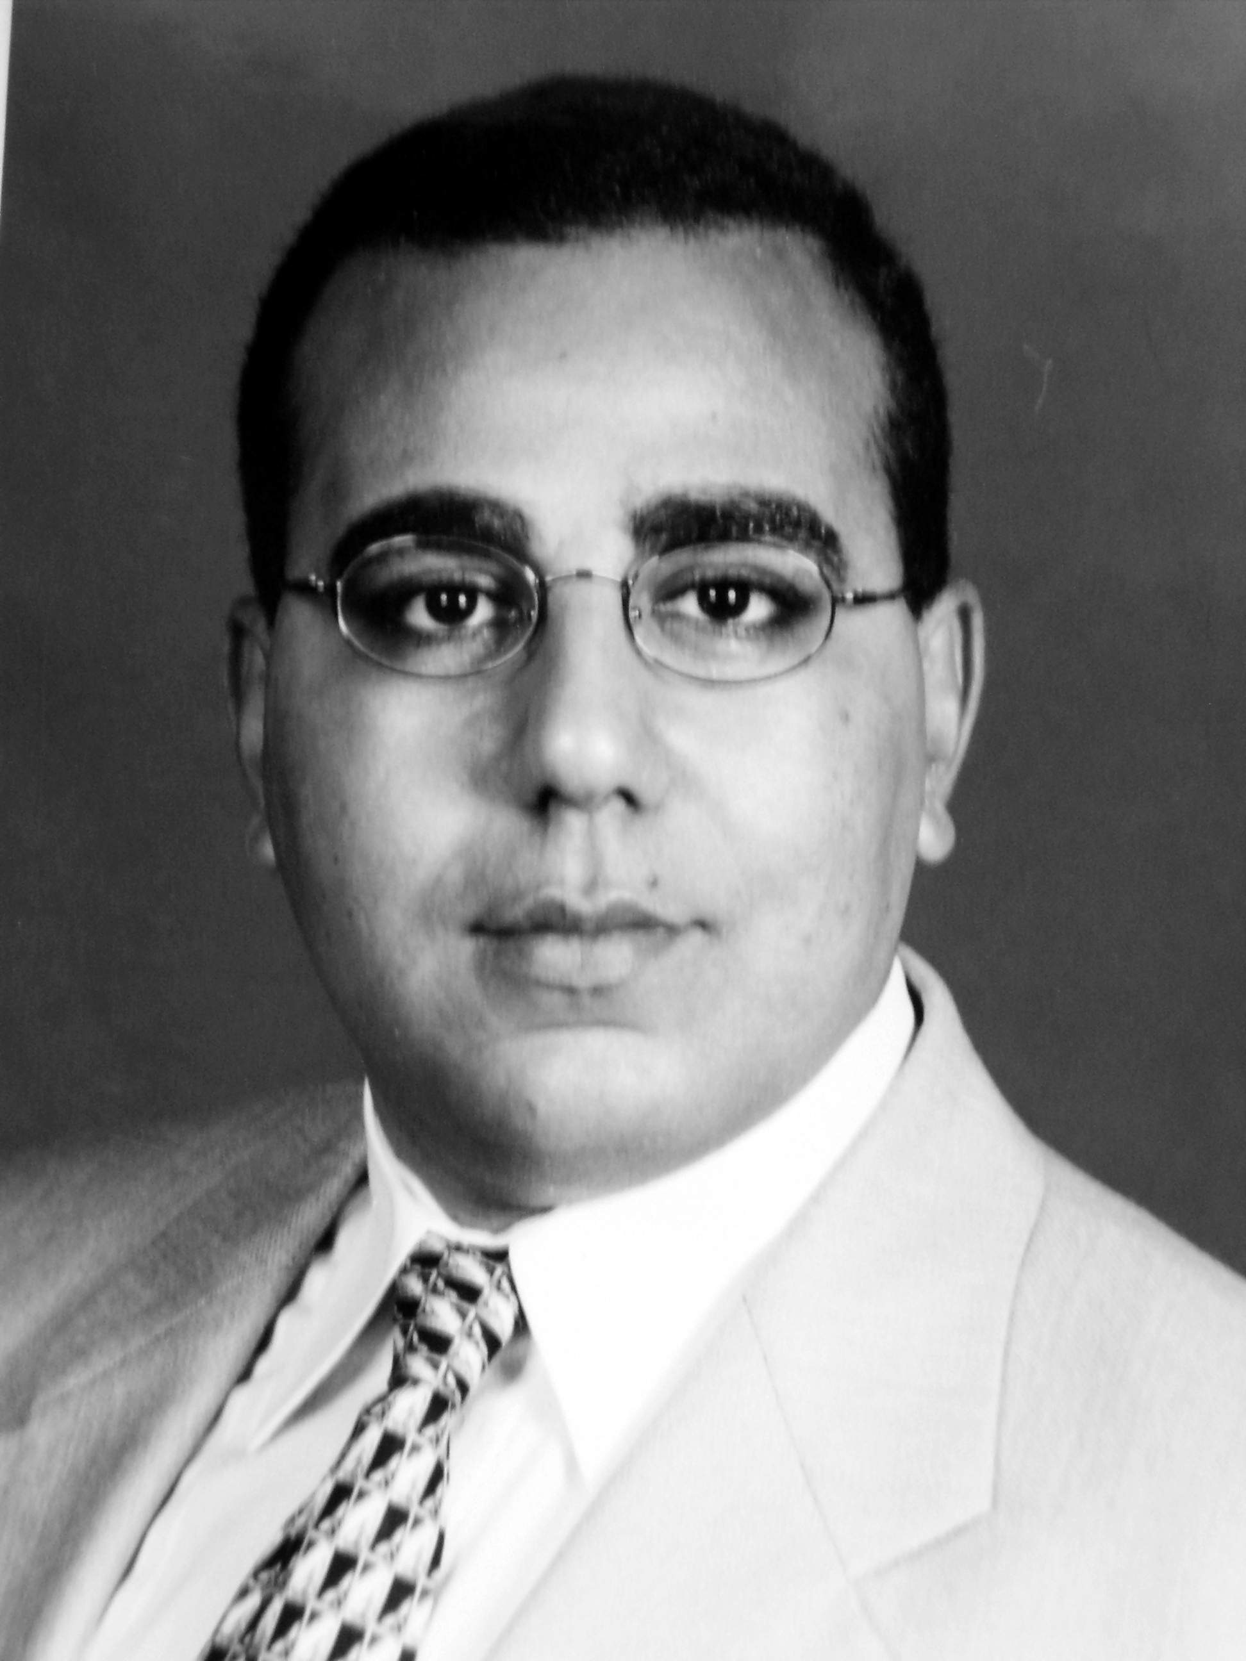
CURRICULUM VITAE

1. PERSONAL DATA:
Name: | Wael Ahmed Abbas Hassanin.
Sex: | Male.
Date of birth: | 29/11/1975
Nationality: | Egyptian.
Marital status: | Married.
Correspondence address: | Gastroenterology and Hepatology unit,  Department of Internal Medicine,  Faculty of Medicine,  Assiut University.  Assiut,  Egypt.  Mobile: +201064236064.  Work Tel. : +20882413826  Work Fax : +20882333327  Home phone: +20882303878, +20882310217
E-Mail: | drwaelabbas@yahoo.com,  wabbas@aun.edu.eg
Current home address: | 9 Goda El-Asady Street,  Sherket Feryal,  Assiut,  Egypt.
Speciality: | Gastroenterology & Hepatology  Endoscopy Consultant.

2. QUALIFICATIONS:
1999 | Bachelors of Medicine and Surgery (MBBCH) “Very Good”.  Faculty of Medicine, Assiut University, Egypt.
2004 | Master Degree in Internal Medicine (M.Sc.)  Faculty of Medicine, Assiut University, Egypt.
2006 | Med Reg Jap Course  Birkbeck University, London, England.
2007-2009 | Clinical Fellowship and advanced training in interventional endoscopy (upper endoscopy, colonoscopy, ERCP, Endoscopic Ultrasound) in Aichi Cancer Center, Nagoya, Japan.
2011 | Medical Doctorate Degree in Internal Medicine

3. POSTS HELD:

From | To | Place of work | Post
1/3/2000 | 28/2/2001 | Assiut University Hospital | House Officer.
1/3/2001 | 28/2/2004 | Assiut University Hospital | Resident doctor in Gastroenterology and Hepatology unit, Internal Medicine department.
1/3/2004 | 28/2/2007 | Assiut University Hospital | Assistant lecturer in Gastroenterology and Hepatology unit, Internal Medicine department.
1/3/2007 | 28/2/2009 | Aichi Cancer Center Hospital and research institute, Nagoya, Japan. | Clinical fellowship, advanced training for interventional endoscopy.
26/5/2011  1/1/2012 | Lecturer of Internal Medicine, Faculty of Medicine, Assuit university.  Consultant of Hepatology and Endoscopy at El-Rajhy Liver University Hospital, Assuit University.

4. PROFESSIONAL REGISTRATION:

- Egyptian Medical License since Marsh 2001 till now.

5. EXPERIENCES:

Clinical practice experience:
- Assiut University Hospital is the biggest hospital in Upper Egypt and is the 3rd biggest in the whole country (1800 bed).
- The Department of Internal Medicine consists of 160 beds including:
- Cardiology Unit (20 beds)
- Nephrology Unit (20 beds)
- Hepatology and Gastroenterology Unit (40 beds)
- Haematology Unit (20 beds)
- Rheumatology Unit (20 beds)
- Endocrine Unit (20 beds)
- General Medicine (20 beds),
- Cardiology intensive care unit (10 of 20 beds).
- Abdominal Ultrasonography Unit, GIT Endoscopy Unit, ERCP Unit, Endosonography unit.
- Stress ECG, Hollter and echocardiography unit.
*During my job in this department, I have worked as a:
- House Officer (Intern) for 4 months,
- Resident doctor for 3 years:
- 2 years in Gastroenterology and Hepatology unit, and endoscopy unit. Attending 3 clinics per week and dealing with all varieties of gastroenterology and hepatology cases. Training for abdominal ultrasonography and diagnostic and therapeutic endoscopy.
- 1 year in Cardiology, Nephrology, Haematology, Endocrinology units, attending 2 clinics per week.
- Assistant Lecturer of Internal Medicine and Gastroenterology from 1/3/2004 involved in teaching to medical students and resident doctors, also gain more experience in diagnostic and therapeutic endoscopy.
- Lecturer of Internal Medicine:
Teaching to undergraduate students (4 hours/week)
Teaching to postgraduate students (2 hour/wwek)
Supervising master degree and Doctorate degree research (3 students).
GIT endoscopy consultant (1 list/week).
Outpatient clinic consultant (1 clinic/week).

6. RESEARCH EXPERIENCES:

Master thesis:
Title: “Serum Fibrotic Markers And Oxidative Stress In Chronic Hepatitis”.
Doctoral degree thesis:
Title “Endoscopic Ultrasound Fine Needle Aspiration and Brush Cytology in Diagnosis of Biliary and Pancreatic Duct Strictures”.

9. MEMBERSHIP:
- Egyptian Medical Syndicate (EMS).
- Conferences Organising Committee, Assiut Faculty of Medicine.
- The Egyptian Society of Endoscopy& Hepato-Gastroenterology (ESEHG).
- The Egyptian Hepato-Pancreato-Biliary Society.
- The Egyptian society of Tropical Medicine and infectious disease.

